Final Year Project Report

**Full Unit – Interim Report**

**Human Computer Interaction**

Riona John

A report submitted in part fulfilment of the degree of

**BSc in Computer Science**

**Supervisor: Zhaohui Luo**



Department of Computer Science

Royal Holloway, University of London

Table of Contents

Table of Contents 2

1. Introduction 3

1.1 Project Specification 3

1.2 Abstract 3

1.3 Aims & Objectives 4

2. Background Theory 5

2.1 Literature Survey 6

3. Interface Breakdown 7

3.1 Mental Health Online Journal 7

3.2 A Parent-guided shape learning tool for young children 13

3.3 A Practice Website for Computer Illiterate Users 17

4. Technical Achievements 19

4.1 Technical Application Achievements 19

5. Software Engineering 20

5.1 Demo Video 20

5.2 Code Breakdown 20

5.3 Testing 24

5.4 Evaluation 29

5.5 Professional Issues 30

6. Future Planning 31

7. Conclusion 34

8. Appendix 35

9. Bibliography 55

# 1. Introduction

## 1.1 Project Specification

Please find it in the appendix.

## 1.2 Abstract

My final year project focuses on Human Computer Interaction (HCI), and I am designing three interfaces that show the different aspects of human computer interaction.

The following section is Background Theory, where I will further explain and explore what HCI is. I will also go over my literature survey.

The following section is Interface Breakdown. I will describe the different interfaces by explaining the different themes I had in my mind when thinking of the original idea, then show sketches of the wireframes I envisioned for that interface. I have also inserted other diagrams, like a site map, that are important in understanding the flow of the interface, which coincides with the different sections of the interface.

Ensuing, I explain my Technical Achievements during this project, as I only originally had a basic concept of the technologies I used. After using these technologies for a while, I better understand the documentation and the different concepts I have used across the interfaces.

The subsequent section is Software Engineering. I talk about my use of code, testing, evaluation of the project so far, and professional issues that came up developing my interfaces.

Since this is my interim report, I still need to complete all the interfaces. I have a section on future planning, which refers to the work I will be doing during Christmas Break before Term 2 and what I also plan to do in Term 2. I will also be concluding the report in the consequent section.

## 1.3 Aims & Objectives

I chose this project because I wanted to understand how different types of users interact with an interface and how designers combat certain issues in order to make my interface more resistant to those issues, and I would like to spend more time researching how these types of issues can be mitigated against and how I can make similar judgements within my ideas to allow my users to interact with my interfaces fully. I would also like to learn how to create an interface that can be used intuitively for different types of users.

I hope to achieve a better understanding on how to make an interface more inclusive through design as well as allowing more people to understand basic computer literacy through understanding which parts of design correlate with computer literacy. I would also like to be able to create a design that instils familiarity and allows children to add to their working memory that will help them retain their new perception and processing of shapes.

HCI is quite broad and I only have a limited time to complete these three interfaces, I am more focused on solving issues from the project specification:

Aesthetics

Design

Navigation

Feedback to the user

Cognitive issues (Memory)

Colour blindness as a visually impaired disability

I will ensure that these issues will be fully explored before implementing any onto my interfaces and going through reasonable research to back my mitigations to make the interface as usable as possible. All of my interfaces will be websites that are directed to different target demographics. Therefore, I will try to match many of the visual parts, such as aesthetics, to all genders. Nowadays, certain websites can be more influenced by feminine/masculine and less inclusive to everyone. (Abrosimova, 2019) This can take up in the form of the colour themes or even when filling out a form you only get a choice of male and female or even take into account different disabilities. So I will consider these factors and make sure to make it as inclusive as possible. Since one of my ideas will be a parent-guided website but a child learning, the navigation must be simple enough to use so that a child can use their cognitive functions to learn from this website. It is important to note that children’s cognitive functions are still developing so this particular interface will require quite simple navigation/format so that they don’t get overwhelmed. Similarly, my third interface will also be teaching something to user requiring me to understand how adults remember information, specifically computer literacy, I believe this links well with HCI as I can see how well a user can interact with an interface by seeing if they better understand how to use computers and different operations.

# 2. Background Theory

Human computer interaction (HCI) combines computer science, cognitive science, and human factors engineering. HCI began to be a popular topic of discussion that appeared in the late 1970s when more people had access to interfaces which affected personal computing. (Dix, n.d.)An example of HCI is through a desktop metaphor demonstrated by the apple Macintosh where you would be able to see files and folders as icons that could be dragged and dropped. However, some people use Linux, where you used commands back then. Even though at the time, it seemed odd to move these icons around, this trend has become part of our everyday lives. This is an excellent example of how HCI can make a user find a process more personal and meaningful to them. (Sawyer, 1992)

Considering HCI is a quite widespread topic, there are several ways to measure how effective the interface’s design is, one suggested method is that there could be four design principles: (1) Learnability/Familiarity, (2) Ergonomics/Human Factors, (3) Consistency/Standards, (4) Feedback/Robustness. (Hinze-Hoare, 2004) The four principles cover the full range of System/User/Input/Output Interaction between a user and an interface. I agree that these principles measure HCI well, as humans will process information in a specific way, understand it, and then receive it in a consistent and familiar design throughout an interface to create feedback that can allow the design to grow. In regard to my interfaces these principles in particular can increase/decrease the usability of my interface: (1) the more difficult it is for the user to interact effectively with the interface the less of a chance they would want to use it regularly and gain the familiarity in using that interface. This learning time can be decreased by making use of the user's existing knowledge. I think this is incredibly important for my interfaces as one of them is an interactive learning tool so therefore the familiarity drives the memorability of the learning for the user. (3) Consistency can be broken down to visual, functional, internal and external. (Nikolov, 2017) These sections all make the interface eliminates confusion and increases familiarity in these interfaces.

## 2.1 Literature Survey

# 3. Interface Breakdown

## 3.1 Mental Health Online Journal

The first interface is a Mental Health Online Journal. When I was doing research on the outlets of releasing stress/anxiety, I saw a lot of examples of using a diary/journal to create a safe space for an individual. (Cheng, Feb 2015) Based on that research, regarding the range of the target demographic (ages 16 -25), I created an online journal. Since writing a journal is a well-known outlet that the demographic regularly uses already for general feelings for mental health can help manage anxiety, reduce stress, and cope with depression since it. (L Renee Watson, n.d.) As journals are supposed to be used regularly, this allows me to explore the theme of familiarity.

Journals are supposed to be personal and that is one of the reasons I would like to make this interface very welcoming and private to a user, so they do have a place to keep their private thoughts.

I believe the demographic I am targeting misunderstand mental health since our surroundings have tailored it towards certain genders. I want to address the problem through aesthetics and using all pronouns to show that anyone can use this interface and that mental health can happen to anyone. I explain inclusive design below and how I try to implement different types of aesthetics to combat the stereotypes that come with mental health.

### Inclusive Design

The 7 principles of inclusive design: Flexibly, Simplicity, Consistency, Perception, Equity, Prevention and Accommodation. (Belman-Adams, April 2022) The feature I’m most focusing on is accommodation and equity as I would like all users to feel welcome and feel safe so I tried to avoid using male and female connotations in reference to aesthetic and colours referencing the societal view on “pink is for girls and blue is boys”. I didn’t just focus on gendered aspects but also the different ages I wanted to reach within my target demographic (16-25 year olds). I wanted the overall design to be relatively simple and classy and neutral, the reason I didn’t add pictorial elements in my proof of concept. I was trying to be more aware and understanding if a user is in an emotional state at that time.

### Wireframes

Below are low-fidelity wireframes to show what each web page could look like. These wireframes are a partial set of designs, just a guideline since I would like to build on the inclusivity side of design so that different types of users can say they would feel comfortable using this application.

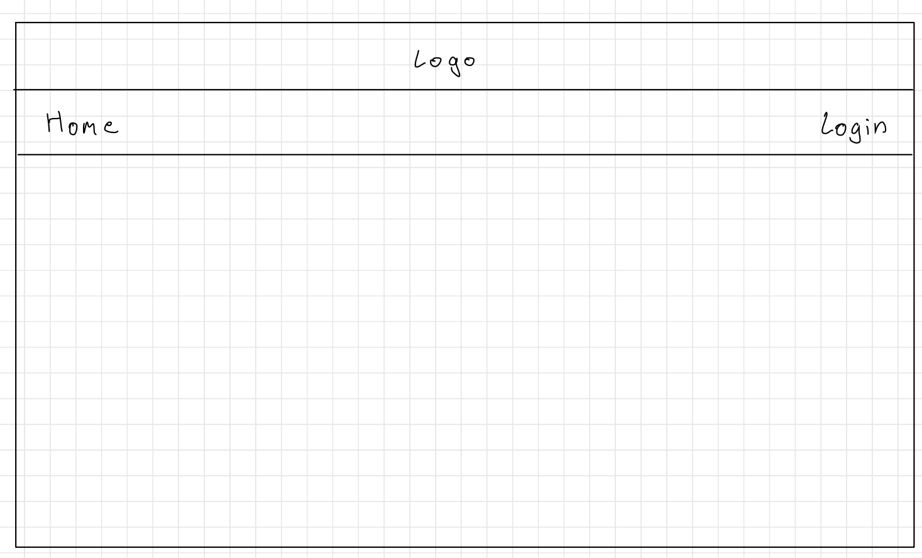

Home Page screen

This will be a link that redirect to this page.

A button that once clicked redirected a user to the login page.

An image or logo that I make myself

Figure 1: Home Page (User has not Logged In yet)

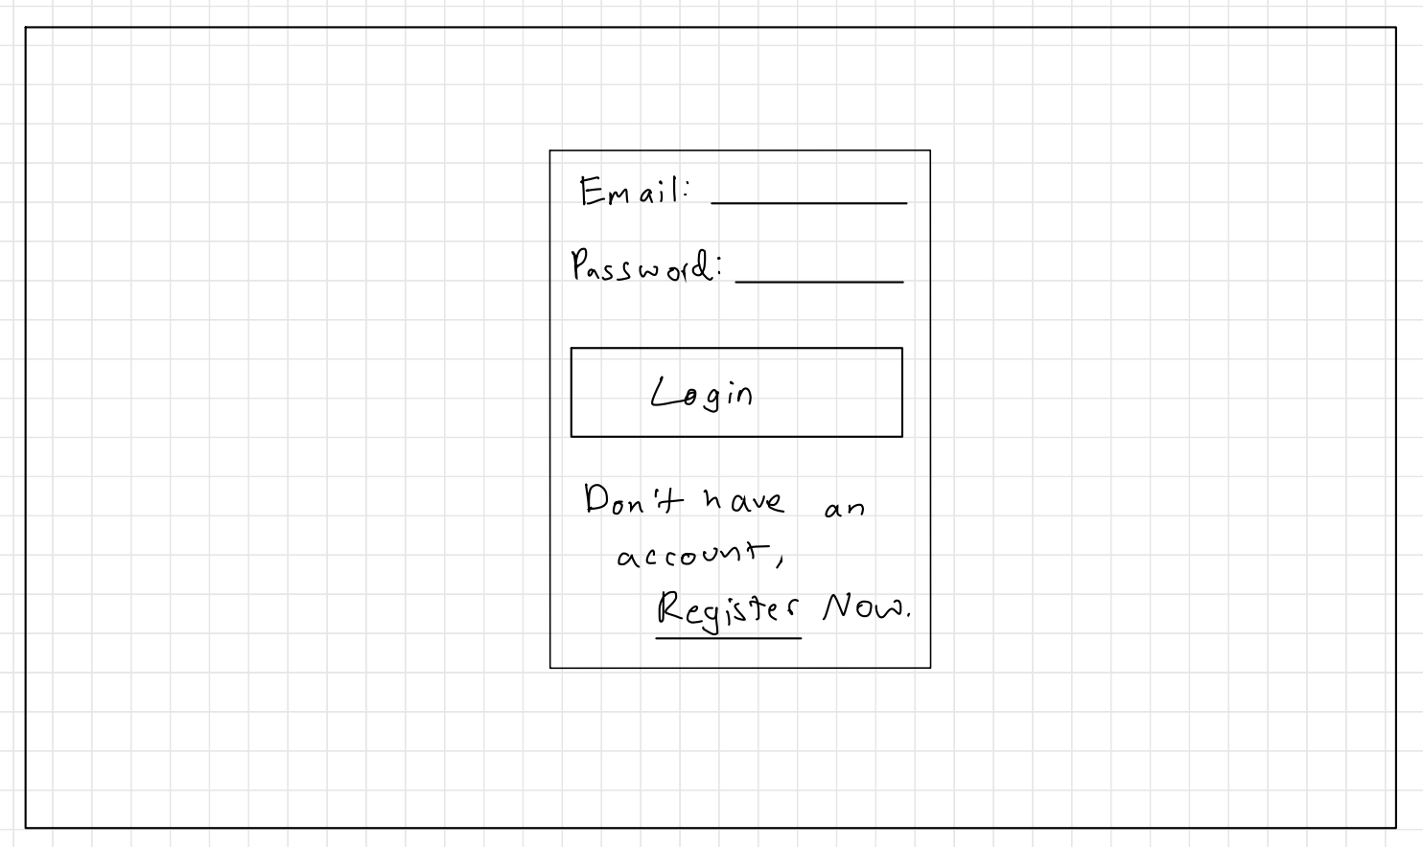

Login Page

Figure 2: Login Screen

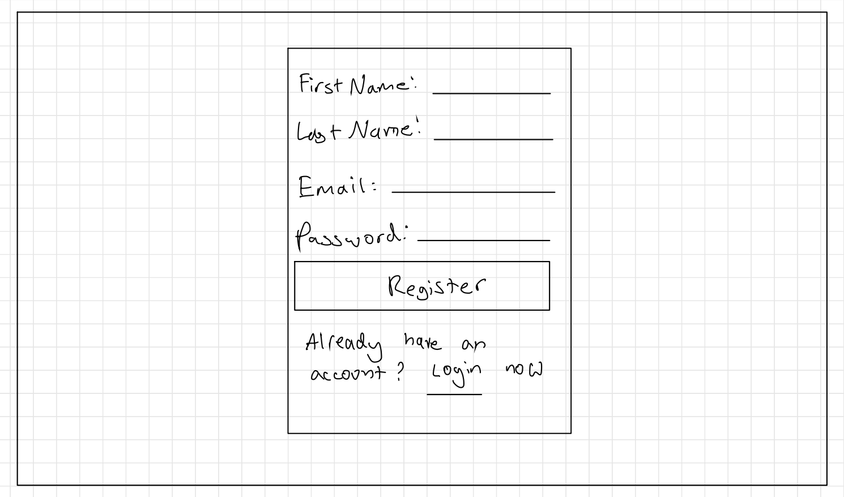

Register Page

Figure 3: Register Screen

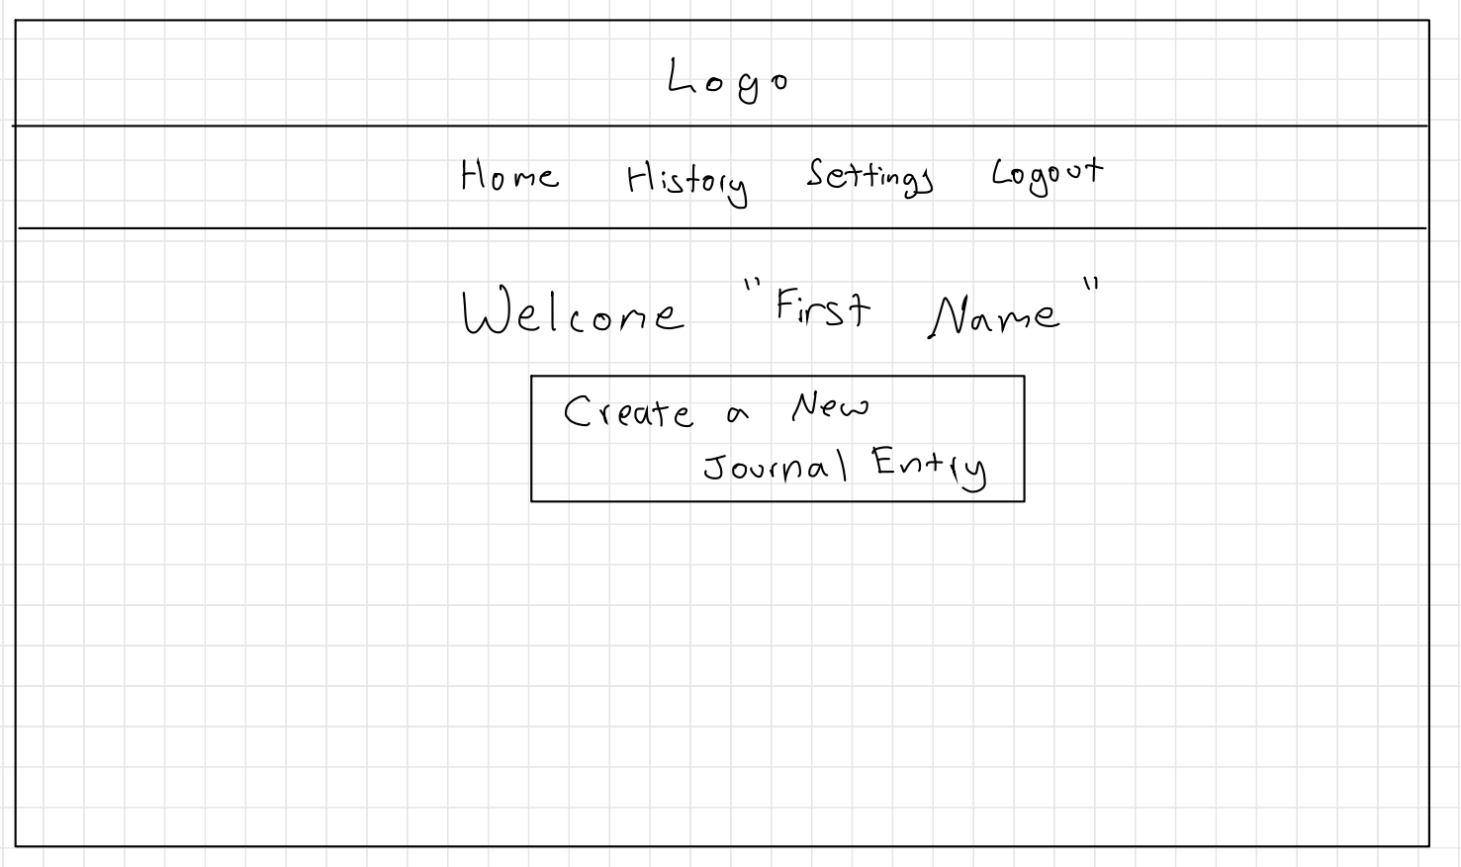

From Register Information

Journal Home Page

Figure 4: Journal Home Page (User Logged In)

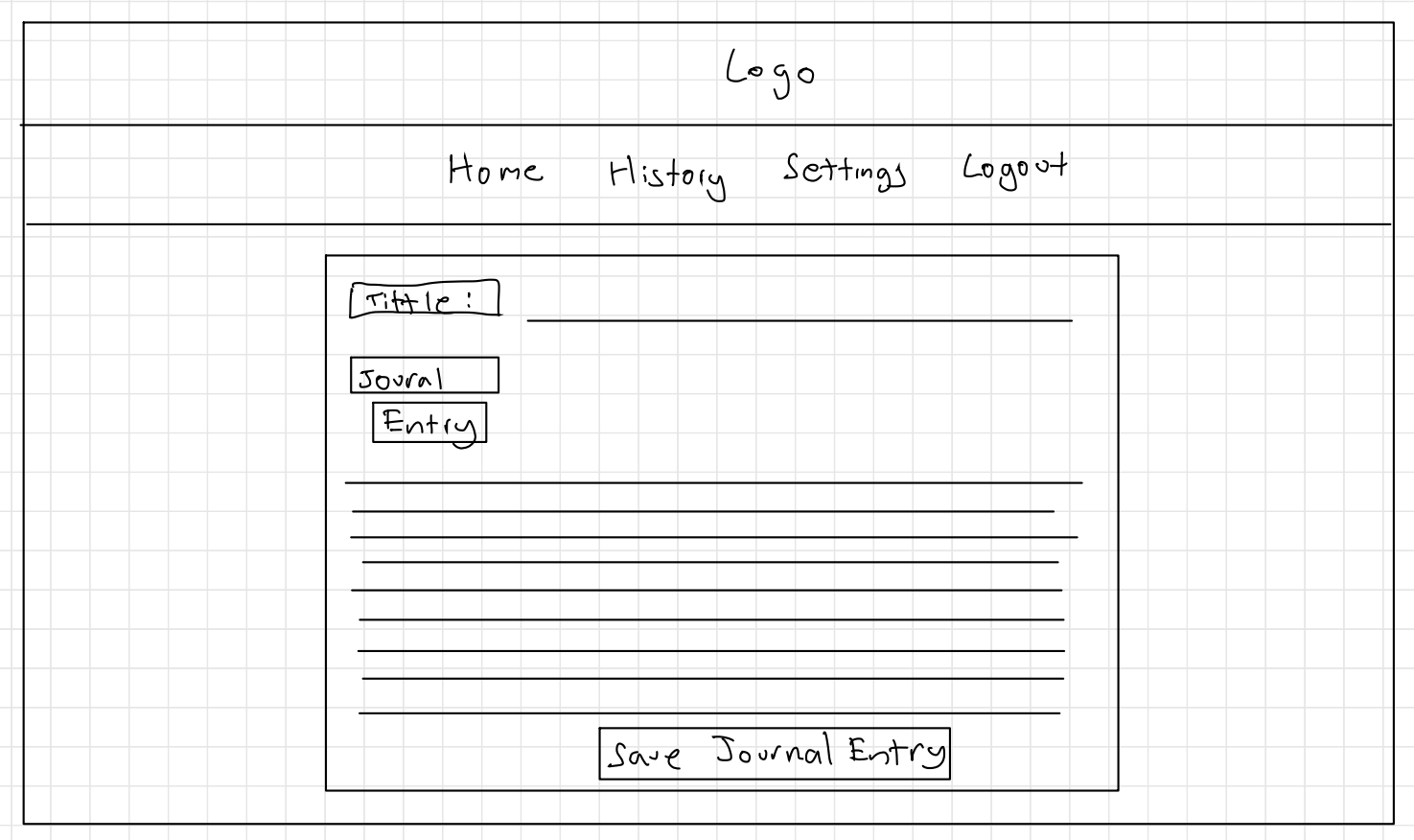

New Journal Entry Page

Figure 5: User creating a Journal Entry

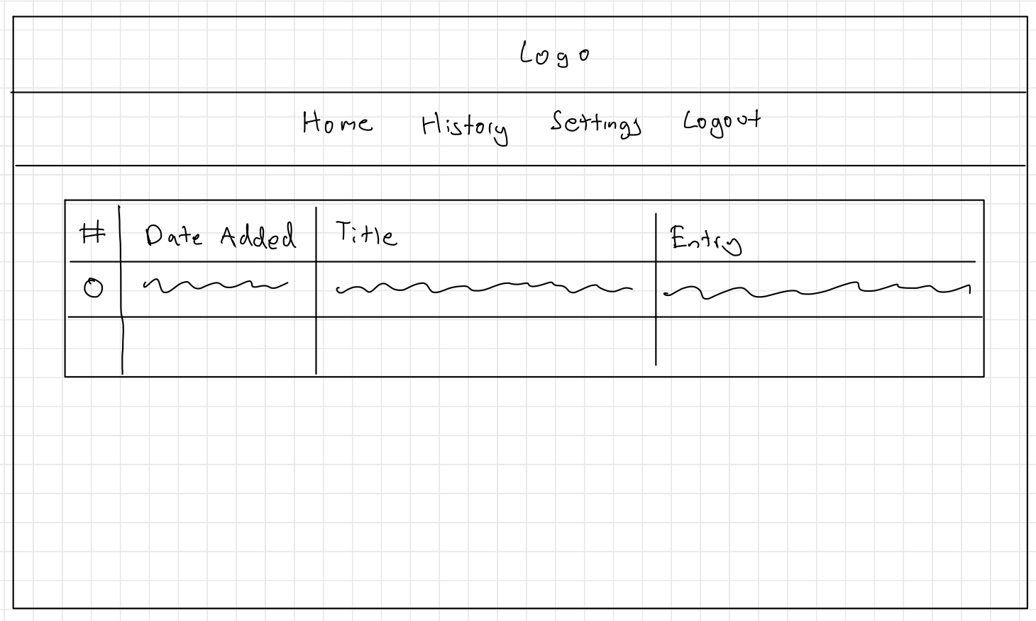

Journal History Page

Figure 6: User can see their previous journal entries

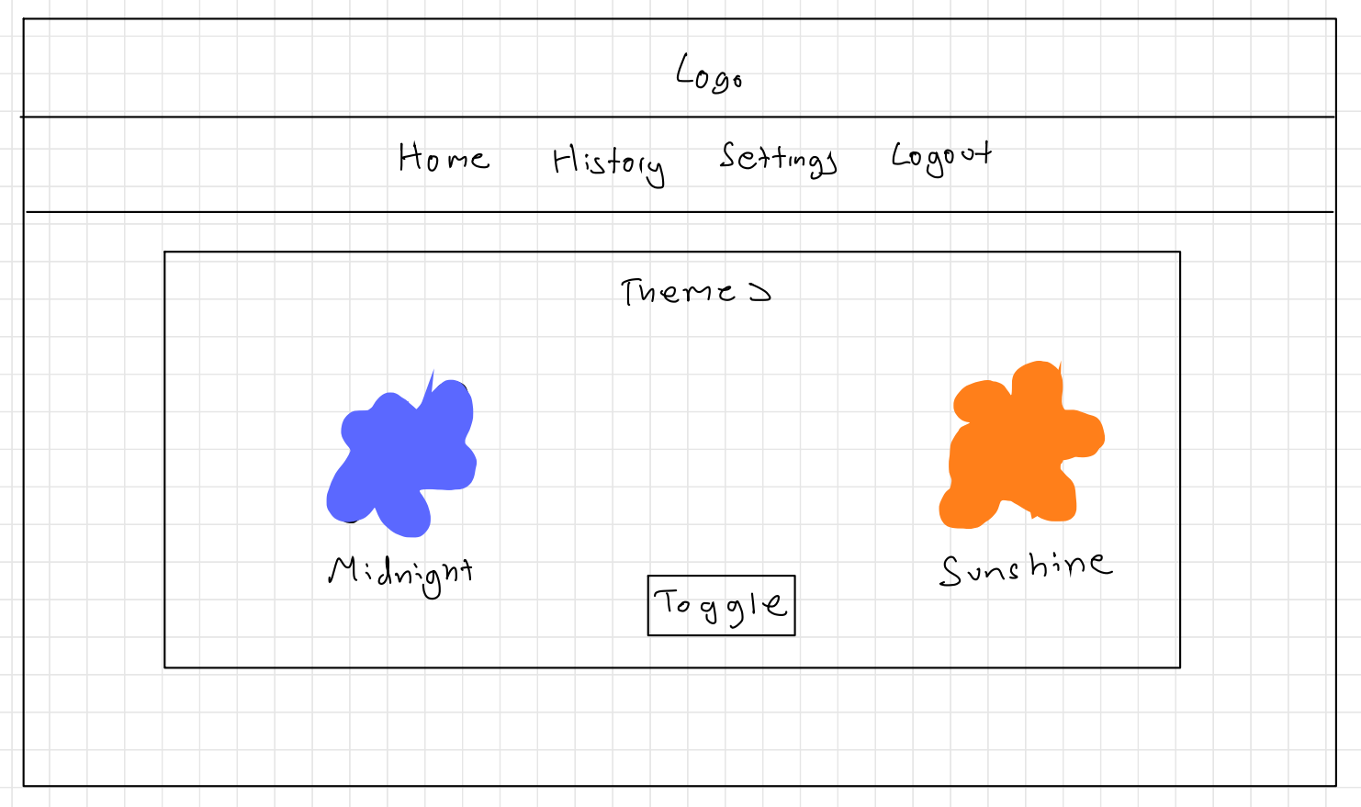

Settings Page

Figure 7: User can change themes on the settings page.

### Site Map

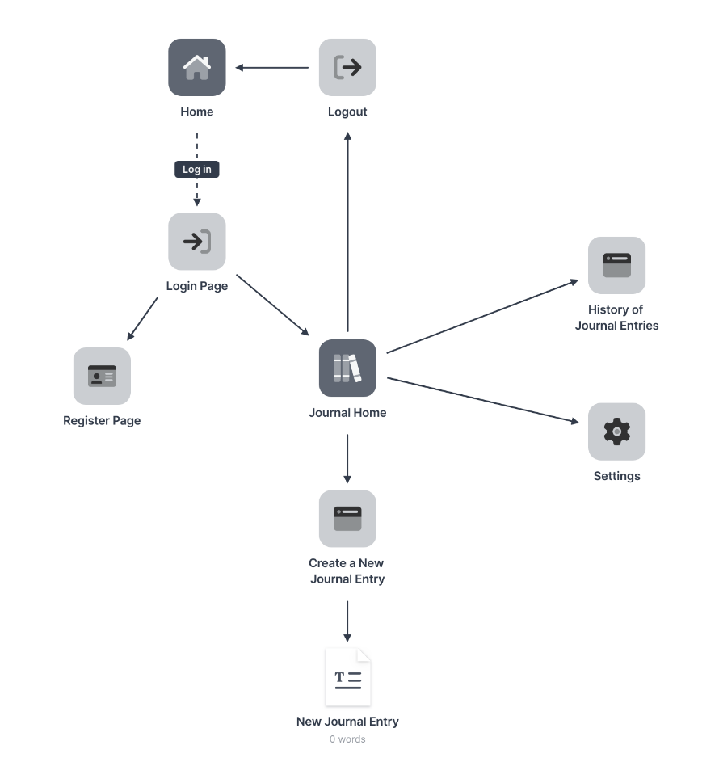

Figure 8: Mental Health Online Journal Site Map

### Design & Interaction Features

### Home Page

Home Page has a navbar that has a home link and a button that directs the user to the login page.

### Login Page

A user will enter their email and password and it will authenticated by the firebase authentication process which will then redirect theme to the journal home page.

### Register Page

A user can easily register by just adding their first name, last name, email and their password to the system through a form which will then automatically sign them in and direct hem to the journal home.

### Navigation Component

I created two navigation components as one is for just a view interaction in the initial home screen and the other navigation bar once logged in has more private actions, like creating a journal entry. The journal home navigation bar includes history, settings and the log out button.

### Create Journal Entry

Once you sign in, you are presented with a container with your first name to add to the customised experience. You will also see a button that will re-direct the user to a journal entry page. It has title text box and an entry text box. Once the user decides they are finished writing their entry, they have the option to save it and then they get directed to the history page to see their past journal entries.

### History of Journal Entries Page

This shows the user all the entries they have written and saved to the database.

### Settings Page

This where a user can change the theme of the website to a customised dark mode called midnight to a light mode that’s also been customised to the colour palette of yellow (as explained before as an inclusive design colour).

## 3.2 A Parent-guided shape learning tool for young children

The second interface is a Shape Learning Tool. I am making this tool parent-guided, as I chose to make a website instead of an app so I tried to factor if the target demographic (18 months – 3 years old+) (Academy, 2017) might struggle to click on the website or interact with it. The reason I didn’t use an app was because I was afraid I wouldn’t be able to pick up the technologies as fast and easily, especially since it didn’t seem feasible with the amount of the time we had.

The reason I picked shapes as the topic to learn is because it sets up children to understand math, sort and categorise, learn letters and numbers, use descriptive vocabulary, use visual discrimination. (BabySparks, 2019) I didn’t just want to make a learning website, I wanted to address an issue or disability and that is why I picked colour-blindness which I try to solve by a grayscale filter, this is explained below.

### Cognitive (Memory) Development

When I researched the topics which are most effective for long-term development, shapes and numbers were the two key topics I encountered. The reason I chose shapes was because I also wanted to explore colour blindness and its effect on memory learning. Since colours and shapes are very common observable traits to young children, they are part of the foundation for higher-level concepts like counting numbers and recognising letters. (Intervention, n.d.)

### Colour blindness affecting design on websites

Colour blind users need to be able to see a different change in state when clicking/hovering on a button on a website to identify an action occurring, e.g. that state being highlighted in a bright contrast colour or underlined. Regarding my shape learning tool, that is one of the reasons I am using a colour blind filter that would turn the image grayscale, and I would already have patterns on the shapes so that users can identify the shapes that way too. (Bigman, 2012)

### Wireframes

Below are low-fidelity wireframes to show what each potential web page could look like. These wireframes are a partial set of designs, just a guideline since I would like to build on improving on subtle hints that would be able to help a general visually disabled user so that colour blind users aren’t the only users that can benefit from this tool.

Home Page

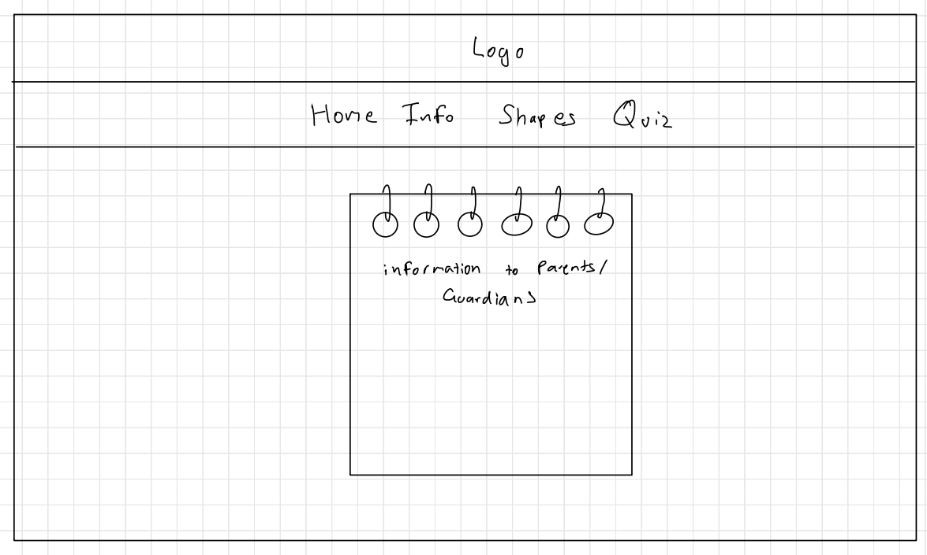

Figure 9: Shape Learning Tool Home Page

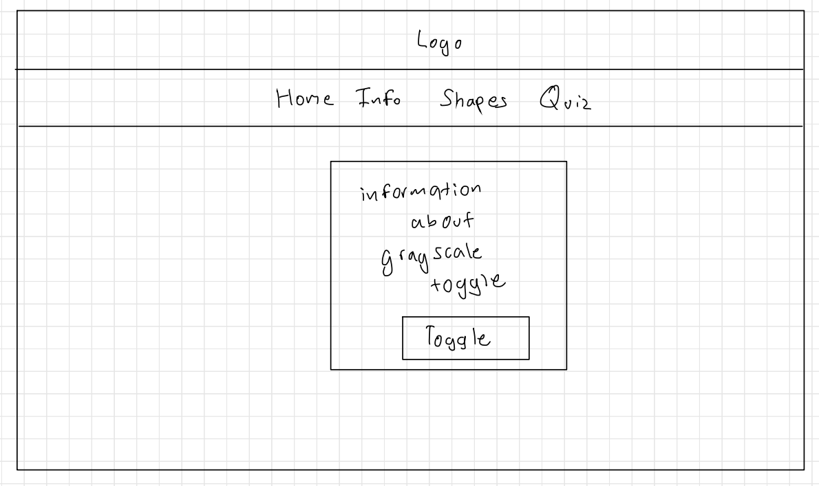

This button will make relevant images grayscale to help colour blind people focus on the shape pattern rather the colour.

Information Page

Figure 10: Information Guide Page (where colour blind users can use a grayscale mode)

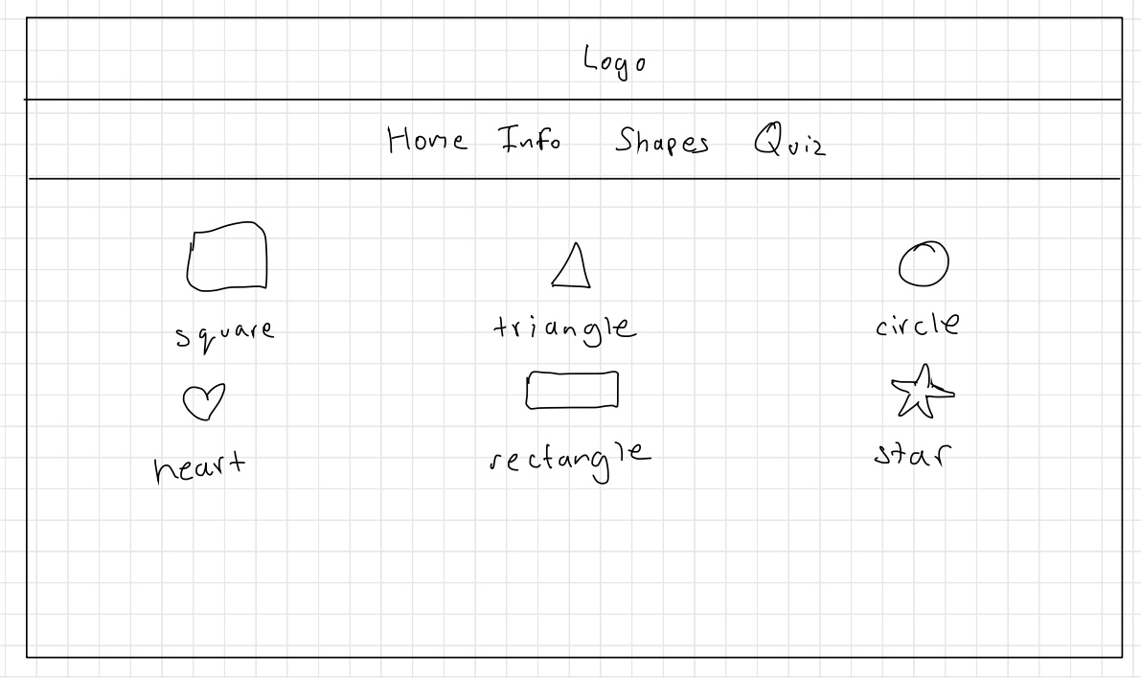

A user can click on the shape name to access the individual page for that shape page.

Shapes Page

Figure 11: Shapes Page

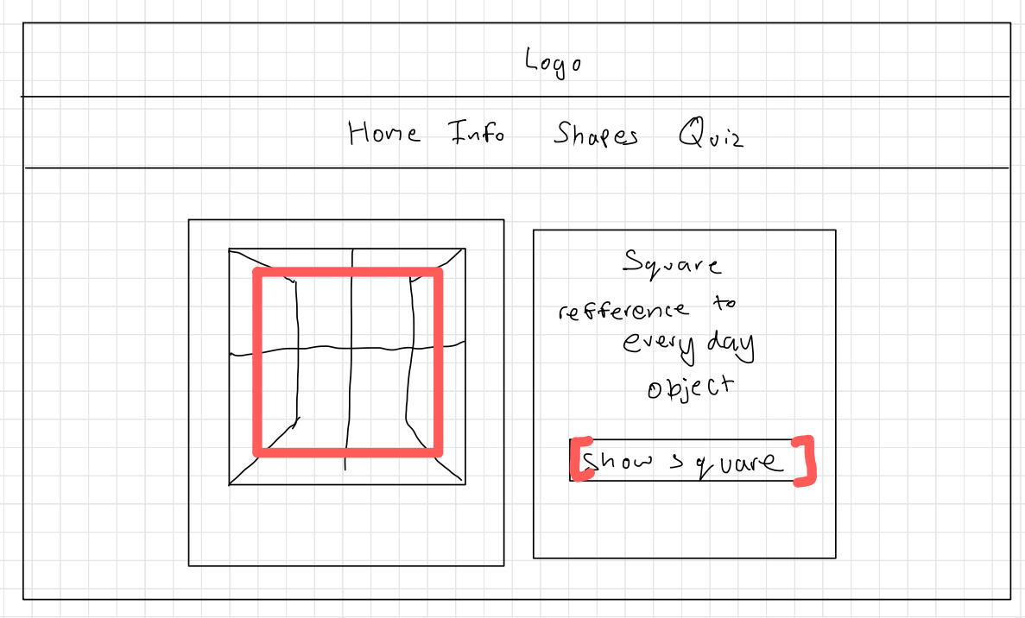

When the user presses the button, the shape that can be seen in the image and is highlighted with colour or/and pattern.

Example Shape Page

Figure 12: An example of what an individual shape page would look like

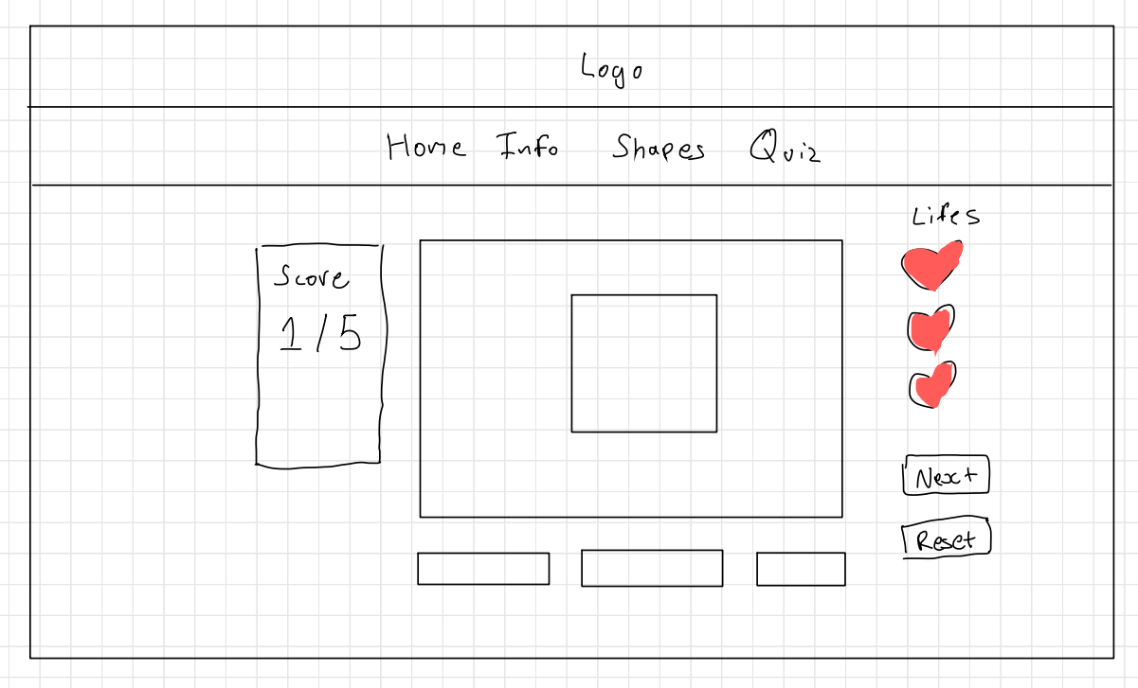

Multiple choice quiz, 5 questions as there is 6 shapes. There will be certain amount of times they can get something wrong (life system)

Experimental Quiz Page

Figure 13: Quiz Page

### Site Map

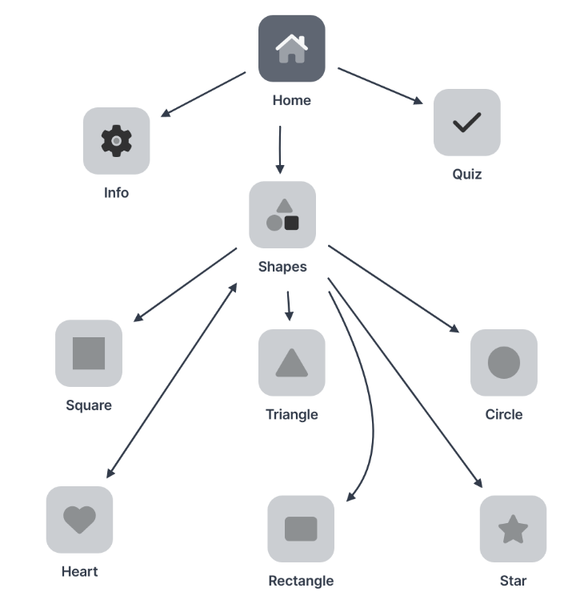

Figure 14: Parent-Guided Shape Learning Tool Site Map

### Design & Interaction Features

### Home Page

This page is currently informing to the parent (user) that this website is a tool to help children learn shapes.

### Info Page

This is where parents are directed from the home page to be able to toggle the “colour blind switch” which should make all relevant images grayscale on the website. Currently can only make the grayscale feature work on the Info Page and not accessible on the other pages.

### Shapes Page

The shapes page is a menu of all the shapes I provide for a child to learn on this website. I created six shapes because I wanted to have enough to test to ensure that the child is learning and should be able to make minimal familiarity with the shapes and their respective colours/patterns I have chosen.

### Example Shape Format page – “Square Shape Page”

Each of the shape pages have an everyday object as an image on the left and a small description asking the user if they can recognise the shape outline, if not there is also button below that description that will make the image highlight the shape.

The reason I used everyday objects to show different shapes is that, I was hoping that when the children aren’t using the website, in their everyday life their brains will make subtle connections, e.g. a window is normally in the shape of a square so the children will then be used to that idea.

### Quiz Page

My plan for this functionality is to show the shape with the pattern and colour or the everyday objects that I have used before (which creates familiarity) and then allow them to choose the answer by multiple choice.

*Note: This functionality hasn’t been implemented yet, and is subject to change.*

## 3.3 A Practice Website for Computer Illiterate Users

It is estimated that the number of people in the UK lacking basic digital skills is declining, but in 2018, 8% of people in the UK (4.3 million people) were estimated to have zero basic digital skills (are unable to do any of the activities described in the five basic digital skills). A further 12% (6.4 million adults) were estimated to only have limited abilities online (missing at least one of the basic digital skills). (Statistics, n.d.) These findings led me to create my third interface which will be a Computer Literacy Tool.

Not having these skills causes what is known as the Digital Divide, which means that some users are disadvantaged and unable to interact and access these interfaces in the same way. Therefore I want to bridge this gap by creating simple accessibility by incorporating some of these skills and teaching these types of users.

### The importance of computer literacy

As an undergraduate student, computer literacy is important to me as otherwise I wouldn’t be able to create this project, for example as I would need to have skills to search errors and writing emails is a key skill I use to communicate to my supervisor. (Hoar, 2014) This interface is to help every one of all ages that I why I want to focus on:

Browser/Search Engines

Word Processing Skills

Communication

There are several ways of measuring these skills, the most common skills are: using equipment, e.g. moving the mouse, typing on the keyboard, browser/search engines, e.g. making sense of how to search effectively, word processing skills, e.g. text formatting, introduction to ‘undo’ and ‘redo’ buttons in an application, communication, e.g. social media: liking a post, writing comments. (Twinkl, n.d.)

### Design & Interaction Features

Since people with computer literacy may struggle to get on to the website there will be a demo video that should be shown to them to show exactly on how to get on to the website.

### Home Page

A short description on what computer literacy is and how this website will try to support user who struggle with this. (Minnesota, n.d.)

### Browser/Search Engine Page

This page will have examples of search bars and browser features, e.g. an empty search bar to search specific keywords to find specific websites that are well known to familiarise them on those of the names of the websites.

### Word Processing Skills

User should be able to understand how to create an email, how to tell difference between emails and URLs. Send/Reply/Reply All/Forward an email.

### Communication (in regard specifically to social media)

I choose in regard to social media since many users use social media indirectly so it would benefit them on how to create a posts, like/comment that post, and understand public and private settings.

*Note: This interface hasn’t been implemented yet, and are subject to change.*

# 4. Technical Achievements

## 4.1 Technical Application Achievements

### React

In my application, I generally use Hooks to change my variable’s value using these methods: useState() and useEffect(). UseState is a Hook that allows you to define a variable that is a current state and also a method that can update the current state. UseEffect allows me to add extra methods to the original function while effecting the original function.

### Bootstrap & React – Bootstrap

React Bootstrap is a form of Bootstrap that is more compatible with React.

Certain components in my interfaces have prebuilt class structures, e.g. “navbar” is a class that bootstrap provides that creates a navigation bar that is presented on the web page. This node module also has the main css file that is imported into my pages to interact with my components that I create as it creates base css for the class structures I use.

React – Bootstrap is a library of convenience as I prefer to use certain components that already have built in css and base structure, this helps me have an initial design that I can add on to easily rather than building the css e.g. buttons.

### CSS

For my 1st interface, I have made 2 different themes which will be covered in Inclusive design. Currently they don’t work interchangeably however this functionality will be worked on over Christmas break.

### Node.js & Node Package Manager (NPM)

Node.js is a framework that can run JavaScript code on your machine while npm is a package manager. Using npm we can install and remove Javascript packages also known as node modules. (ALAVALA, n.d.)

### React interacting with Firebase

For my 1st interface I use Firebase to store my data, in doing so it means I have to create a firebase configuration file that has all the methods I require as well as my links and ids to the different types of databases I use. For example, databaseURL: https://mental-health-online-journal-default-rtdb.firebaseio.com is the connection URL for my real-time database.

### Firebase

For my first interface, authentication is needed so I use the authentication service to authenticate by email and a password. This stores the different created users, their account created date, their user ID.

I use the Cloud Firestore Database to also store the authenticated users in a database which stores their personal information such as their first name and last name and which authProvider they used to create the account.

I use the Real-time Database to store my user’s personal journal entries under their personal user id. Each of these journal entries will have their own id as well. I reference this database to show the journal entries in a table as well, so that the users have access to their previously written entries.

# 5. Software Engineering

## 5.1 Demo Video

Below is a link to a demo of my proof of concepts so far:

Insert YouTube link

## 5.2 Code Breakdown

### Mental Health Online Journal

### Journal History component

|  |
| --- |
| //Reference: https://www.youtube.com/watch?v=NueuZjC9_Og  //Creator: The Amazing Codeverse  import React, { useEffect, useState } from 'react';  import { ref, onValue } from "firebase/database";  import { useAuthState } from "react-firebase-hooks/auth";  import { auth, journalEntryDatabase } from "../firebaseConfig/firebase";  import { Table } from "react-bootstrap";  import 'bootstrap/dist/css/bootstrap.min.css';  /**   * JournalHistoryTable is referencing the firebase real-time database to get a user's individual journal entries.   *   * @returns a table of previous journal entries   */  export function JournalHistoryTable() {    const [tableData, setTableData] = useState([]);    const [user] = useAuthState(auth); //current user logged in    const [currentTheme, setTheme] = useState(      localStorage.getItem('currentTheme') || ''    );    useEffect(() => {      localStorage.setItem('currentTheme', currentTheme);      //localStorage requires the page to store the currentTheme as a variable that will help other pages in the website to follow the correct css style.      setTheme(currentTheme);      document.body.className = currentTheme;    }, [currentTheme]);    useEffect(() => {      try {        const journalRef = ref(journalEntryDatabase, "/journalEntries/" + user?.uid);        /*this is referencing the firebase real-time database where it stores user’ journal entries */        onValue(journalRef, (snapshot) => {          let entryRecords = [];          snapshot.forEach(childSnapshot => {            /**the reason it is checking for a childSnapshot is because the reference             * only isolates the current user’s journal but not the individual entries**/            let keyRecord = childSnapshot.key;            let data = childSnapshot.val();            entryRecords.push({ "key": keyRecord, "data": data });            /**individual entries being added to an array so that             * can be set to the table’s contents**/          });          setTableData(entryRecords);        });      } catch (error) {        alert("No entries saved!");      }    }, [user]);    /**dependent on the current user    (refreshes the results if a different user is logged in)**/    return (      <>        <Table bordered className='historyTable'>          {/* displaying the results of my query */}          <thead>            <tr>              <th>#</th>              <th>Date Added</th>              <th>Title</th>              <th>Entry</th>            </tr>          </thead>          <tbody>            {tableData.map((row, index) => {              /**it goes through the values of the entries,               * and takes specific parameters and return it to the user**/              return (                <tr>                  <td>{index}</td>                  <td>{row.data.currentDate}</td>                  <td>{row.data.title}</td>                  <td>{row.data.entry}</td>                </tr>              )            })}          </tbody>        </Table>      </>    )  } |

### Toggle Theme (Midnight and Morning Sunshine)

|  |
| --- |
| import React, { useState, useEffect } from 'react';  import 'bootstrap/dist/css/bootstrap.min.css';  import '../css/OverallCSS.css';  import defaultTheme from '../graphics/default-theme-resize.png';  import sunshineTheme from '../graphics/morning-sunshine-resize.png';  /**   * Settings Container gives a user a choice to change themes.   *   * @returns Container showing the two themes and a toggle button.   */  const SettingsContainer = () => {      const [currentTheme, setTheme] = useState(          localStorage.getItem('currentTheme') || ''      );      useEffect(() => {          localStorage.setItem('currentTheme', currentTheme);         /* localStorage requires the page to store the currentTheme as a variable that will help other pages in the website to follow the correct css style.*/          document.body.className = currentTheme;      }, [currentTheme]);      function toggleThemes() {          if (currentTheme === "") { /*midnight being the default theme*/              setTheme("sunshine-theme");          } else {              setTheme("");          }      }      return (          <>              <br />              <div class="container">                  <div class="row">                      <div class="col">                          <h2>Themes</h2>                      </div>                  </div>                  <div class="row">                      <div class="col">                          <img                              src={defaultTheme}                              alt="Default"                          />                      </div>                      <div class="col">                          <img                              src={sunshineTheme}                              alt="morning-sunshine"                          />                      </div>                  </div>                  <div class="row">                      <div class="col">                          <h1>Midnight</h1>                      </div>                      <div class="col">                          <h1>Morning Sunshine</h1>                      </div>                  </div>                  <div class="row">                      <div class="col">                          <button class="btn-toggle" onClick={toggleThemes}>Toggle Themes</button>                      </div>                  </div>              </div>          </>      )  }  export default SettingsContainer |

## 5.3 Evaluation

I am only evaluating the interfaces I have written code for, since it would seem unrealistic to predict how I evaluate the third interface as it has not been implemented and the interface may change.

(How to test usability – generate a survey for a user to fill out a Nielsen heuristics questionnaire.)

### 5.3.1 Mental Health Online Journal

Previously in my aim and objectives I mentioned that the issues I would like to solve are aesthetics, design, navigation, feedback to the user.

So after making the majority of my functionality for this interface, I believe I have tackled aesthetics by adding and have the accessibility to the themes so that users have the choice to change how they want to interact visually with the interface.

I think the navigation bar, I have created fits well with consistency or and standards within measuring how effective the interface’s design is. (Hinze-Hoare, 2004) Since the nav-bar is fixed is deigned horizontally which is a common practise for websites. I don’t have too many instances where the user would require feedback from the interface, therefore the main effect that I have included are alerts that make the user aware if they have saved their journal entry for example.

### 5.3.2 A Parent-guided shape learning tool

The two specific issues I solve in my learning tool are cognitive issues (Memory) and colour blindness as a visually impaired disability specifically to the target demographic of young children (18 months – 3 years old+). The way I am trying to support children who have visually impaired disabilities is to have a grayscale filter available to change relevant shape images with a grayscale filter on. This feature would be able to be toggled so that it could still help other visual disabilities, as specific colours and bright contrast colours can help to identify the shapes and allow neurotypical children to have access to the colours.

Learnability or and familiarity design is used - for example all the shapes pages have the same structure as there is an everyday object that looks similar to the shape, and parent can interact and have a button to show the image overlaid on the object. (Hinze-Hoare, 2004) Therefore these objects would be engrained into the young minds and so should allow them to start being familiarised with the shape if they saw a similar version of the object they were introduced to. Again similar to the toggle themes in my interfaces, the grayscale filter is similar in the way to implement it. Currently it doesn’t currently work on other pages than its current page which would like to fix over the Christmas break.

## 5.4 Professional Issues

### Using Open Source Code

Since I was inexperienced with firebase capabilities for my first interface, I used open-source code for my login and register containers and functionality. I referred to the author’s name in the classes I used their code in. Also, my repository has a reference file that explicitly says which classes or components originated with his code. (Deosthale, n.d.)

I also used YouTube videos as guidelines on what react is and understanding the different components that allowed me to become more familiar with the various features I could create.

Node.js is also an open-source tool that helped me run the Javascript, allowing me to see the preview of my code on my browser.

### Plagiarism

Since I have used open-source code, there is a risk that I copied their code, but since I referenced their work, I acknowledged that their original code is theirs, and I have adjusted their original code to suit my program better.

# 6. Future Planning

|  |  |  |  |
| --- | --- | --- | --- |
| **Over Christmas Break (12/12/2002 to 09/01/2023)** | | | |
| **Start of the week** | **Milestones** | **Additional Notes** | **Personal Deadlines** |
| **12/12/2022** | Focusing on Mental Health Online Journal | I want to add more pictorial elements – I’ll be looking into to see how feasible it will be to create a drag and drop system to add stickers to the page. To decorate the journal pages. |  |
|  |  | I also would like to look into and try to implement a way for the user to see their journal entries in the original format that was given to them. | **26/12/2022** |
| **26/12/2022** | Focusing on the Parent-guided shape learning tool for young children | I will need to research the most effective way to test children to see if they learnt anything or gain some familiarity of shapes. (For the quiz page functionality.) |  |
|  |  | Implement the base part of the quiz functionality. |  |
|  |  |  | **02/01/2022** |
| **02/01/2022** | Focusing on A Practice Website for Computer Illiterate Users | Start Making the wireframes and understanding which components I have to make by planning out the types of structures I need to use/div containers. |  |
|  |  |  | **Term 2 start on 09/01/2023** |

|  |  |  |  |
| --- | --- | --- | --- |
| **Term 2** | | | |
| **09/01/2023** | Making any changes that is needed form getting feedback on my interim. | The feedback on the interim should be made as soon as possible. |  |
|  | Building up my 3rd interface. Adding base functionality. |  |  |
|  | Start creating components for Browser/Search Engine Page, Word Processing Skills, and Communication Pages |  |  |
| **23/01/2023** | Work on my report | The report has to be explained well enough even if you couldn’t see my interfaces. |  |
| **06/02/2023** | Going back to my computer illiterate user tool, just finishing up little details. | Adding specific design features accordingly.  E.g. Email creation and adding icons to identify certain things. |  |
|  | Try to create a draft final report. | To try and receive some last main feedback before drafting the final report. |  |
| **20/02/2023** | Looking at all my interfaces and cleaning up all of them. | At this point, I shouldn’t be changing anything major, and focus on cleaning it up. |  |
|  | Doing any testing required. | Making sure all interfaces are at a required standard of functionality. |  |
| **06/03/2023** | Making sure all functionality is there and working. | I will need to start finalising my report soon, so I need to be able to show and demo all my interfaces. |  |
|  | Do any more research that is needed. | This should be finished by this week so it’s ready to add/edit on my final report. |  |
|  | Make sure all my testing is finished. | To make sure all my tests can recorded and explained in the report. |  |
| **20/03/2023** | Complete all my interface and finish off my report. | Both will be due this week. | **Final report/Programs – Due 24/03/23** |

### 6.1 Cypress Testing Library

Currently I have some testing, which is in the report later on, however when I have completed all of my functionality for all the interfaces. I want to use the cypress library for the rest of my testing which focuses on end-to end testing: which means to measure the success of the working order of a complex product in a start-to-finish process. (Gillis, n.d.) I prefer to do this at the end of my development so that I will be able to make sure that I will test every possibility a user could take as a journey on my website, especially since it is a website test automation library. Which refers to the “test user” clicking and typing on its own rather than myself or a beta test user using the system. I prefer this to TDD (Test Driven Development) because I think it shows a more reliable representation of how the user is interacting with the system rather than just presenting that the system works.

# 7. Conclusion

To summarise, I have created most of the main functionality of my first interface, and I have only recently started the second one. However, as stated previously, the quiz component will be implemented over the Christmas break.

Going back to the issues I highlighted within my aims & objectives: aesthetics, design, navigation, feedback to the user, cognitive issues (memory), and colour blindness as a visually impaired disability, I am confident that I have either created an interaction that supports the issue well or will be in the process of creating an interaction to improve the outcomes of these issues. For example, the concept of themes in my first interface allows anyone using the interface, regardless of their other qualities, to use it. The option of the “dark or light mode” creates an aesthetic that is not connoted to any negative thoughts, but rather the yellow tones in the “light mode” create a happy and safe atmosphere.

Similar to this toggle theme change, my second interface implements a grayscale filter. This supports colour blindness as a visually impaired disability and allows the filter to be more general rather than having specific filters for the different types of colour blindness so that it could help other visual disabilities as well.

While I have yet to start my third interface, I have a decent perspective on how the different pages I will create will help solve these similar issues.

# 8. Appendix

## 8.1 Testing

You can find all the figures below.

### Mental Health Online Journal

|  |  |  |  |  |
| --- | --- | --- | --- | --- |
| **Test Number** | **Test Description** | **Expected Output** | **Actual Output** | **Screenshot /Figure** |
| **1** | Users can load website and see home page. | Website is presented to the user can see the home and Login button. | Website is presented to the user can see the home and Login button. | Figure 15 |
| **2** | Users can click on the register link on the login page (assuming that they already clicked the login button to show the login screen) and see the register page. | User can click on the register link on the login page and sees the register page. | User can click on the register link on the login page and sees the register page. | Figure 16 |
| **3** | Users get an error message if they leave everything blank on the register screen. | Users should get two error messages: “Please enter your details” and “There is an invalid email address” | User puts nothing in and gets two error messages: “Please enter your details” and “There is an invalid email address” | Figure 17, 18 |
| **4** | Users can register by entering their details. | User can enter their first name, last name, email-address, and password. | User can enter their first name: “Riona”, last name: “John”, email-address: “testing@email.com”, and password: “testing”. | Figure 19, 20 |
| **5** | User can successfully login and see their first name: “Riona” | User should be able to see their first name in a container and see a button “Create a New Journal Entry” | User sees their first name: “Riona” in a container and see a button “Create a New Journal Entry” | Figure 21 |
| **6** | Users can click on Login button and be redirected to the login screen. | User should be able to click on the login button and shown the login screen. | User clicks on the login button and is shown the login screen. | Figure 22 |
| **7** | Users can login with an email and password successfully. | User can login with their details. | User logins with testing@email.com”, and password: “testing” successfully and see home screen. | Figure 23, 24, 25 |
| **8** | User can see an error alert if nothing is inputted in the textboxes. | User leaves the input textboxes blank and see according error message. | User leaves the input textboxes blank and see according error message. | Figure 26 |
| **9** | Users input the wrong details in the login page. | Users input the wrong details in the login page and see error message. | Users input the wrong details in the login page and see an error message: “auth/user-not-found”. | Figure 27 |
| **10** | User create a new journal by clicking on the button: “Create a New Journal Entry” and shows the journal page. | User clicks on the button: “Create a New Journal Entry” and shows the journal page. | User clicks on the button: “Create a New Journal Entry” and shows the journal page. | Figure 28 |
| **11** | Users can add a journal entry and then re-directed to the history page. | Users should be able to write an entry, save it and receive a confirmation message before being redirected to the journal history pages. | Users should be able to write an entry, save it and receive a confirmation message before being redirected to the journal history pages. | Figure 29, 30, 31 |
| **12** | Users can access the settings page. Users should be displayed with a container showing the 2 different themes: Midnight (Dark Mode) and Morning Sunshine (Light/Happy Mode). | User should be able to toggle between the themes. | User should be able to toggle between the themes. | Figure 32, 33, 34 |
| **13** | Users can Logout by clicking on the button | User can click Logout and be redirected to the original home screen. | User clicks Logout and then gets redirected to the original home screen. | Figure 35 |

### A Parent-guided shape learning tool

|  |  |  |  |  |
| --- | --- | --- | --- | --- |
| **Test Number** | **Test Description** | **Expected Output** | **Actual Output** | **Screenshot /Figure** |
| **1** | User can load website. | Website is presented to user. | Website is presented to user. | Figure 36 |
| **2** | A user can access the information (info) page and displays. | Info page is shown. | Info page is shown. | Figure 37 |
| **3** | If toggle button is clicked, all images turn grayscale. (including if user goes to a different page) | Images turn grayscale. | Images turn grayscale.  Informational home page doesn’t as it is not needed to. | Figure 38, 39 |
| **4** | User can access the shape page and see all shapes and shape name displayed. | User should see a square, triangle, circle, heart, rectangle and star images and respective names. | User sees a square, triangle, circle, heart, rectangle and star images and respective names. | Figure 40 |
| **5** | User should be able to click on the shape name and be redirected to the square page. | Users can click on “Square” and see the square page. | Users see the square page once clicking on “Square”. | Figure 41 |
| **6** |  | Users can click on “Triangle” and see the triangle page. | Users see the triangle page once clicking on “Triangle”. | Figure 42 |
| **7** |  | Users can click on “Circle” and see the circle page. | Users see the circle page once clicking on “Circle”. | Figure 43 |
| **8** |  | Users can click on “Heart” and see the heart page. | Users see the heart page once clicking on “Heart”. | Figure 44 |
| **9** |  | Users can click on “Rectangle” and see the rectangle page. | Users see the rectangle page once clicking on “Rectangle”. | Figure 45 |
| **10** |  | Users can click on “Star” and see the star page. | Users see the star page once clicking on “Star”. | Figure 46 |
| **11** | User should be able to click on the show  “shape name “and see the patterned shape over the image. | User click on “Show Square” and should see a patterned square appear. | User clicks “Show Square” and sees a patterned square appear. | Figure 47 |
| **12** |  | User click on “Show Triangle” and should see a patterned triangle appear. | User clicks “Show Triangle” and sees a patterned triangle appear. | Figure 48 |
| **13** |  | User click on “Show Circle” and should see a patterned circle appear. | User clicks “Show Circle” and sees a patterned circle appear. | Figure 49 |
| **14** |  | User click on “Show Heart” and should see a patterned heart appear. | User clicks “Show Heart” and sees a patterned heart appear. | Figure 50 |
| **15** |  | User click on “Show Rectangle” and should see a patterned rectangle appear. | User clicks “Show Rectangle” and sees a patterned rectangle appear. | Figure 51 |
| **16** |  | User click on “Show Star” and should see a patterned star appear. | User clicks “Show Star” and sees a patterned star appear. | Figure 52 |
| **17** | User can click on quiz page and see empty page with the header and nav bar. | User should see quiz page. | User see displayed quiz page. (Currently Empty, explained previously that this functionality has not been implemented yet.) | Figure 53 |

### 8.2 Project Specification

**Aims:**To compare various user interfaces and evaluate their design in terms of human usability

**Background:**User interfaces are becoming increasingly more important as the world conducts a web- based conversation with itself, along with the continuing computerization of products and facilities. When interfaces are situated in safety-critical contexts, their design and usability can be a matter of life and death: consider the fatalities associated with the Therac-25 radiation therapy machine. The USA Gore-Bush presidential campaign in 2000 was significantly disrupted by voter confusion over the computerized butterfly ballot design. Other classic interface issues include users mistaking their CD-ROM tray for a cupholder, or looking for the "any key”. In terms of e-commerce, companies invest in the design of customer web-sites with consideration to visual appeal and usability. Current directions for interface applications include mobile, wearable and ubiquitous computing.

HCI issues include: colour theory; human perception; haptic/tactile technology; gender / age /cultural / special needs issues; speech recognition / generation; graphic design; cognitive issues such as memory, learning and problem solving; design of fonts; navigation; feedback to the user; usability; aesthetics; ethical issues; and interface problems.

For this project the student will design and implement at least 3 different software interfaces (just focussing on the interface) - for instance a web-page/site, a data-base, an interactive sketch tool, a distance learning facility, or a GUI. A more challenging goal is to implement a mobile interface such as for the Android operating system for touchscreen devices.

The report will comprise a comprehensive survey on HCI discussing both software and hardware interfaces. In particular, the software interfaces implemented by the student will be evaluated in the report in terms of HCI principles.

This project is not based on any of your courses, therefore some HCI material will be provided.

**Early Deliverables**

1. A text-based (non-interactive) monochrome web-page
2. A colourful web-site including images and navigation
3. GUI built with buttons etc.
4. Report: about 15 pages including sketches of designs.

**Final Deliverables**

1. Design and implement a more advanced interface(s)
2. Complete report
3. The programs must have an object-oriented design, using modern software engineering principles.
4. The report will describe the software engineering processes involved in generating your software.
5. The report will include comparisons of interfaces with a discussion of their meanings.
6. The report will include a User Manual.

**Prerequisites:**Interaction Design module (PC3001)

**Reading**

http://hci.rwth-aachen.de/HCIBooks

http://www.netmagazine.com/features/top-50-books-web-designers-and-developers

### 8.3 Git Lab Diary (Development Log)

### 8.3.1 Final Year Project Diary Entries

**26/09/2022**

This week I want to achieve creating different templates of react projects:

* login using set username and password variables
* register form that will save data to a database application (firebase)
* play around with design aspects to see how to make interface aesthetically pleasing

**28/09/2022**

I have achieved setting up a login system if the username and password was set. I also know how to save information to a firebase real time database.

I will be working on how to retrieve information to database to authenticate someone.

**30/09/2022**

I have now completed all my tutorials for using firebase and now can add, update, delete, and retrieve data from my database. I will be looking into how integrate specific React-Bootstrap components for design purposes.

I am currently drawing up some wireframes for my mental health journal - this means I will be researching HCI theories on website layout to ensure I can work on my idea of inclusive design.

**02/10/2022**

I recently found out there is a specific way of authentication in firebase so I have now decided to use that method when I will eventually set up my first interface. The reason I'm using firebase's authentication and Firestore database instead of making my own from will be because it is easier to set up as I have done a tutorial already and it also doesn't require too much set up, which will allow me to focus mon the design aspect of my interfaces rather than a simple functionality such as creating an account and logging into the interface.

I still have yet decided how I'm designing my interfaces, so I will be working on wireframes (planed layouts of my pages), creating my deliverables this week and compiling a folder of all the images I would like to use, including colour schemes to fit with my inclusive design.

I will also be reading on how to implement a software engineering technique into my project so I can discuss it in my report, as I have no need to use design patterns instead I will be using TDD. This will most likely be either unit testing, if possible; I have heard of a technique to show like a demo but as a test rather than a demo to present.

Therefore by 5th/6th of October, I will be ready to start creating the base layout of my mental health journal.

**04/10/2022**

I did some image sampling for my interfaces to make it easier to add interactive components.

I also tried some testing with a tool called cypress. Cypress is a Javascript testing tool that tests end-to-end. I will be using this for interaction testing?

**06/10/2022**

I have now done the authentication however I would still like to use a container component within the page rather than building within the page. I will be building the online journal page next and seeing how to access journal pages.

**11/10/2022**

I have been sick, so the past couple of days, so I'm working on the journal entry page and finding a way to save it to a database with the user's email to differentiate from different user's entries. The email will be a unique identifier since no two accounts can have the same email address.

**13/10/2022**

I have been really struggling on how to save the title, entry, current date and email to a real-time database. So I might take a pause on that functionality and focus more on design and the other interactions my user will use.

In the coming week, I will also be looking to test the functionality that I have already completed.

**15/10/2022**

Since I am struggling to save journal entries, I'm still going to build the table that can show previous entries even it is empty to show my original design for the history page. I'm going to try and stop worrying about if it works or doesn't and just try and see if I can create my main elements and get it on to the page. As even though functionality is important, I want to make sure that a user can be able still interact with the rest of the available features that I wanted to implement such as changing the colour settings to make the design of the website feel more inclusive.

**18/10/2022**

I have figured how to save journal entries and how to save multiple entries to one user. Now I will be working on how to present the multiple entries in a table format to show the history of the journal entries. I will also be focusing on adding images to brighten up my journal and not make it so bland in design and colour.

My next focus will be transferring all these achievements on to the interim report as I haven't kept up on it as much I would have liked. So I would like to at least finish up technical achievements and interface breakdown for my 1st interface.

**21/10/2022**

I worked on the history table today, it doesn't work yet, still trying to debug what contents are being read and if the structure I have created is actually being updated. I also decided on creating an alternative theme, however I still don't understand how to exchange the two themes within the interface. I researched it and it may not be possible with the browser I'm currently using to test the website so may need to revaluate where I deploy and edit my website.

**24/10/2022**

I need to accomplish these tasks:

finish re-designed wireframes for the mental health online journal

Present journal entries on to history page -> currently it works but isn't going through the individual journal entries.

Inter-changing aesthetic themes to work -> currently only works by overwriting the first style sheet that is imported.

Create simple wireframes for 2nd interface, in preparation to start the 2nd interface.

Simple documentation for the first interface.

**27/10/2022**

I have now completely finished all the base functionality of my 1st interface. I would like to finish my last bit of css, to change theme before focusing on my 2nd interface prep (Wireframes, compare and contrast of other learning platforms, node modules required.)

Hopefully starting on 31st I will have created at least base React app for my 2nd interface.

**31/10/2022**

I was unable to fix the toggle theme, but I have put it on my backlog until I have more time to revisit the first interface and work on the feedback that was also given to me by my supervisor; which was to add more pictorial elements to the webpage.

I have officially started my 2nd interface, this week I will be working on the navigation bar and getting together the images that I will be using within my tool, this includes the everyday objects, and shapes. By the end of the week the base design should be complete. I will also research on what type of quiz functionality I would like to do hopefully one that should engage most children, and how to make the images instantly become grayscale through a method or css.

**03/11/2022**

I am currently making base functionality for my 2nd interface and making sure to include bright colours and images that will make sure to help with users who are affected by colour blindness as bright colours can be contrast and make it easier to identify certain colours.

The rest of the week will be building other base pages, I still need to collect everyday object pictures that the shapes can go over or highlight to be more recognisable.

Doing research on and writing up my findings in the interim report:

* When is something recognisable and familiar to children
* Quiz functionality will be most effective towards learning and usability
* General cognitive memory skills for 18 months - 3 yrs. old (might increase my target demographic up till 6/7 yrs.)

**07/11/2022**

I have started to create the containers for each of the shape pages, next I will work on the grayscale method to help colour blind people. I will finish these containers by tomorrow properly.

**12/11/2022**

I am focusing on the interim report but I will be trying again to try and make my toggle themes (mental-health-online-journal) as I really would like to showcase it in my interim "code breakdown" section.

I might try the same way on the grayscale img for the shape learning tool.

**18/11/2022**

I am still working on the interim report, doing feedback from supervisor and doing code clean up alongside.

Hoping to get the interim done by the weekend so the presentation slides can be filled with content.

**24/11/2022**

I will be changing my css to fit more of a dark mode theme, however will need to makes sure it isn't going to create depressing reaction for users as it is a mental health journal.

Still working on my report, and will film video this weekend.

### 8.4 Mental Health Online Journal testing references

|  |
| --- |
| Figure 15 |
| Figure 16 |

|  |
| --- |
| Figure 17    Figure 18 |
| Figure 19    Figure 20 |
| Figure 21 |
| Figure 22 |
| Figure 23    Figure 24    Figure 25 |
| Figure 26 |
| Figure 27 |
| Figure 28 |
| Figure 29    Figure 30    Figure 31 |
| Figure 32    Figure 33    Figure 34 |
| Figure 35 |

### 8.5 A Parent-guided shape learning tool testing references

|  |
| --- |
| Figure 36 |

|  |
| --- |
| Figure 37 |
| Figure 38    Figure 39 |
| Figure 40 |
| Figure 41 |
| Figure 42 |
| Figure 43 |
| Figure 44 |
| Figure 45 |
| Figure 46 |
| Figure 47 |
| Figure 48 |
| Figure 49 |
| Figure 50 |
| Figure 51 |
| Figure 52 |
| Figure 53 |

# 9. Bibliography

Abrosimova, M., 2019. *Did this website just assume my gender?.* [Online]   
Available at: https://uxplanet.org/did-this-website-just-assume-my-gender-3b05c75e7207

Academy, A. C., 2017. [Online]   
Available at: https://austinchildrensacademy.org/aca-blog/children-learning-shapes-and-colors/

ALAVALA, V. R., n.d. *What is the difference between node.js runtime and npm package manager options while installing node.JS?.* [Online]   
Available at: https://stackoverflow.com/questions/41675848/what-is-the-difference-between-node-js-runtime-and-npm-package-manager-options-w

BabySparks, 2019. [Online]   
Available at: https://babysparks.com/2019/05/28/why-learning-shapes-colors-is-so-important/

Belman-Adams, B., April 2022. [Online]   
Available at: https://elementor.com/blog/inclusive-web-design/

Bigman, A., 2012. *Why all designers need to understand color blindness.* [Online]   
Available at: https://99designs.co.uk/blog/tips/designers-need-to-understand-color-blindness/

Cheng, S.-T. P. K. J. H. M., Feb 2015. *Improving mental health in health care practitioners: Randomized controlled trial of a gratitude intervention.,* s.l.: s.n.

Deosthale, A., n.d. [Online]   
Available at: https://github.com/atharvadeosthale/firebase-auth-article/tree/master/src

Dix, A., n.d. [Online]   
Available at: https://www.interaction-design.org/literature/topics/human-computer-interaction

Gillis, A. S., n.d. *end-to-end testing.* [Online]   
Available at: https://www.techtarget.com/searchsoftwarequality/definition/End-to-end-testing

Hinze-Hoare, V., 2004. *4 Principles Fundamental to Design Practice for human centred systems,* s.l.: s.n.

Hoar, R., 2014. *Generally Educated In The 21st Century: The Importance Of Computer Literacy In An Undergraduate Curriculum,* s.l.: s.n.

Intervention, H., n.d. *Learning about Colors and Shapes.* [Online]   
Available at: https://www.honuintervention.com/single-post/2017/03/29/learning-about-colors-and-shapes

L Renee Watson, M. F. P. B., n.d. *Journaling for Mental Health.* [Online]   
Available at: https://www.urmc.rochester.edu/encyclopedia/content.aspx?ContentID=4552&ContentTypeID=1

Minnesota, L., n.d. *NORTHSTAR Digital Literacy,* s.l.: s.n.

Nikolov, A., 2017. *Design principle: Consistency.* [Online]   
Available at: https://uxdesign.cc/design-principle-consistency-6b0cf7e7339f

Sawyer, P. &. C. A. &. S. I. &. M. J., 1992. Object-Oriented Database Systems: a Framework for User Interface Development..

Statistics, O. f. N., n.d. *Exploring the UK’s digital divide.* [Online]   
Available at: https://www.ons.gov.uk/peoplepopulationandcommunity/householdcharacteristics/homeinternetandsocialmediausage/articles/exploringtheuksdigitaldivide/2019-03-04

Twinkl, n.d. [Online]   
Available at: https://www.twinkl.co.uk/teaching-wiki/computer-literacy